Capstone Assignment
Course Title: Deep Learning Architectures and Techniques
Course Code: ETMMDL274
Name : Ekta
Roll No : 2501940029
Submitted to : Mr. Shahid Wani
📄 Experiment 1: Feedforward Neural Network (FNN)
1. Problem Statement
The objective of this experiment is to design and implement a Feedforward Neural Network (FNN) for a classification task. The model is trained to predict whether a person’s income exceeds $50K per year using a tabular dataset (Adult Income Dataset).

2. Data Preprocessing
Data preprocessing is an important step to prepare the dataset for training.
Steps Performed:
- Handling Missing Values:
Missing values represented by '?' were replaced with NaN and removed.
- Encoding Categorical Variables:
Categorical features such as workclass, education, and occupation were converted into numerical format using One-Hot Encoding.
- Feature Scaling:
All numerical features were standardized using StandardScaler to improve model performance.
- Train-Test Split:
The dataset was split into 80% training data and 20% testing data.

3. Model Design
The Feedforward Neural Network consists of:
- Input Layer: Number of neurons equal to number of features
- Hidden Layer 1: 64 neurons with ReLU activation
- Hidden Layer 2: 32 neurons with ReLU activation
- Dropout Layers: Added to reduce overfitting
- Output Layer: 1 neuron with Sigmoid activation (binary classificatio
4. Training
- Loss Function: Binary Cross-Entropy
- Optimizer: Adam
- Batch Size: 32
- Epochs: 15
The model was trained using training data with a validation split of 20%.
5. Evaluation Metrics
The performance of the model was evaluated using:
- Accuracy: Measures correctness of predictions
- Validation Loss: Indicates model generalization
- Training vs Validation Curves: Used to analyze learning behavior
6. Results
- The model achieved good accuracy on the test dataset.
- Training and validation accuracy increased over epochs.
- Loss decreased steadily, indicating proper learning.
- (Graphs of accuracy and loss are included in the results section.)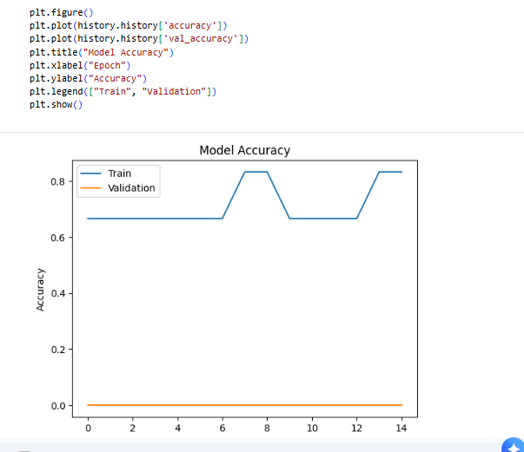
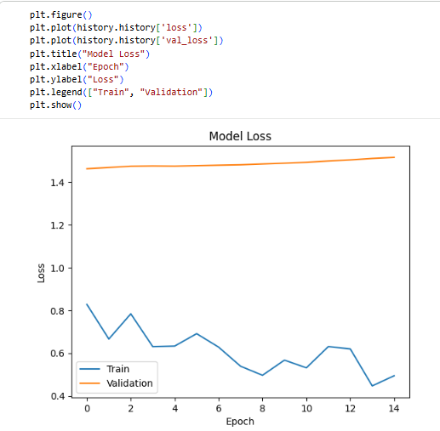

7. Analysis
Effect of Number of Layers
- Increasing hidden layers improved model performance initially.
- Too many layers can lead to overfitting.
Overfitting vs Underfitting
- Overfitting occurs when training accuracy is high but validation accuracy is low.
- This was controlled using dropout layers.
Regularization
- Dropout (0.3) was used to reduce overfitting.
- It randomly disables neurons during training, improving generalization.
📄 Experiment 2: Convolutional Neural Network (CNN) for Image Classification
1. Problem Statement
The objective of this experiment is to implement a Convolutional Neural Network (CNN) for image classification. The model is trained to classify clothing items into different categories using the Fashion-MNIST dataset.

2. Data Handling
Dataset Description
The Fashion-MNIST dataset consists of grayscale images of size 28×28 pixels belonging to 10 classes such as T-shirt, trouser, dress, etc.
Steps Performed:
- Loading Dataset:
The dataset was loaded using tensorflow.keras.datasets.
- Normalization:
Pixel values were scaled from 0–255 to 0–1 to improve training performance.
- Train-Validation-Test Split:
  - Training data: 80%
  - Validation data: 20% (from training set)
  - Testing data: Separate dataset
3. CNN Architecture
The CNN model consists of the following layers:
- Convolutional Layer 1:
32 filters with kernel size (3×3), activation = ReLU
- MaxPooling Layer 1:
Pool size (2×2)
- Convolutional Layer 2:
64 filters with kernel size (3×3), activation = ReLU
- MaxPooling Layer 2:
Pool size (2×2)
- Flatten Layer:
Converts 2D feature maps into 1D vector
- Fully Connected Layer:
Dense layer with 64 neurons (ReLU)
- Dropout Layer:
Dropout rate = 0.3 to reduce overfitting
- Output Layer:
10 neurons with Softmax activation
4. Training Setup
- Loss Function: Categorical Cross-Entropy
- Optimizer: Adam
- Batch Size: 32
- Epochs: 10
The model was trained using batch training with validation data.
5. Evaluation Metrics
The performance of the model was evaluated using:
- Accuracy: Measures overall correctness
- Precision: Measures correctness of positive predictions
- Recall: Measures ability to find all positive samples
- F1-score: Harmonic mean of precision and recall
- Confusion Matrix: Shows classification performance for each class
6. Visualization
1. Sample Predictions
- Displayed sample test images with predicted labels
2. Training vs Validation Graphs
- Accuracy vs Epoch graph
- Loss vs Epoch graph
These graphs help in understanding model performance and convergence.
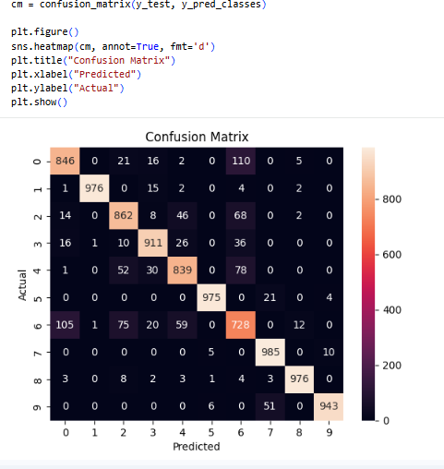
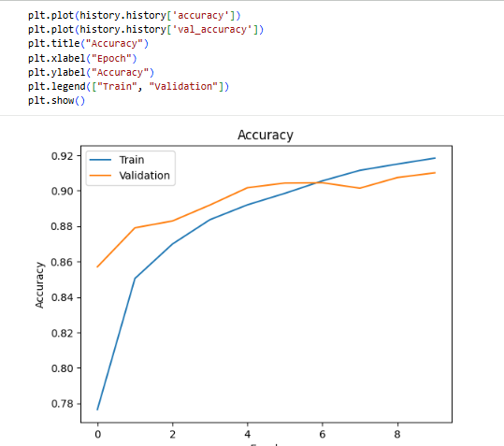
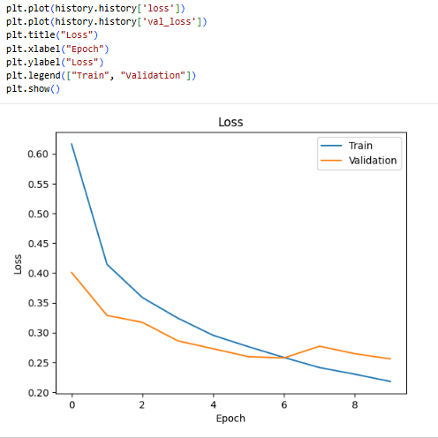
7. Results
- The CNN achieved high accuracy on the test dataset
- Training accuracy improved steadily over epochs
- Validation accuracy followed a similar trend, indicating good generalization
- Loss decreased continuously during training
- 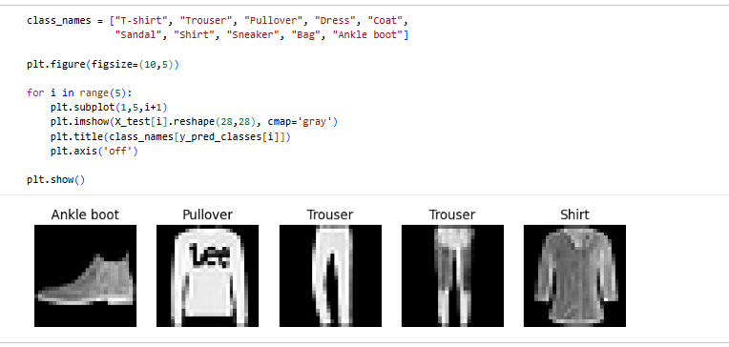
8. Analysis
1. Effect of Kernel Size and Filters
- Smaller kernels (3×3) effectively captured image features
- Increasing number of filters improved feature extraction but increased computation

2. Overfitting Handling
- Dropout layer (0.3) was used to reduce overfitting
- Model showed balanced training and validation performance

3. Model Performance
- CNN performed significantly better than traditional models for image data
- Able to learn spatial features automatically
📄 Experiment 3: LSTM for Sequence Modeling
1. Problem Statement
The objective of this experiment is to implement a Long Short-Term Memory (LSTM) based model for sequence prediction. The model is used to predict future values in a time-series dataset such as stock prices or temperature data.
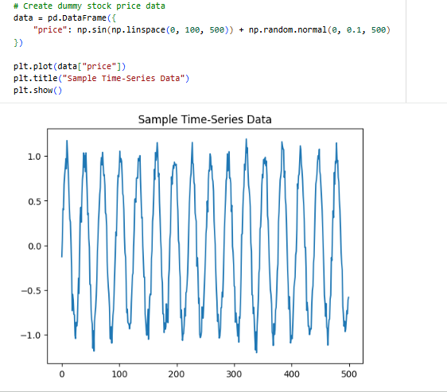
2. Data Preprocessing
Dataset Description
A time-series dataset representing sequential data (e.g., stock prices) was used for prediction.

Steps Performed:
- Sequence Windowing:
The data was converted into sequences using a fixed window size (sequence length = 20).
Each input sequence consists of past 20 values used to predict the next value.
- Normalization:
Data was scaled between 0 and 1 using MinMaxScaler to improve model performance.
- Train-Test Split:
  - 80% data used for training
  - 20% data used for testing
3. Model Architecture
The LSTM model consists of:
- LSTM Layer 1:
50 units with return_sequences=True
- LSTM Layer 2:
50 units
- Dense Layer:
1 neuron for output (next value prediction)
4. Training
- Loss Function: Mean Squared Error (MSE)
- Optimizer: Adam
- Batch Size: 32
- Epochs: 10
The model was trained using training data and validated on test data.
5. Evaluation Metrics
The model performance was evaluated using:
- Mean Squared Error (MSE): Measures average squared difference between actual and predicted values
- Loss Curves: Used to analyze training and validation performance
6. Results
- The model successfully learned the pattern in the time-series data
- Predictions closely followed the actual values
- Loss decreased over epochs, indicating proper training
Graphs Included:
- Loss vs Epoch curve
- Actual vs Predicted values plot
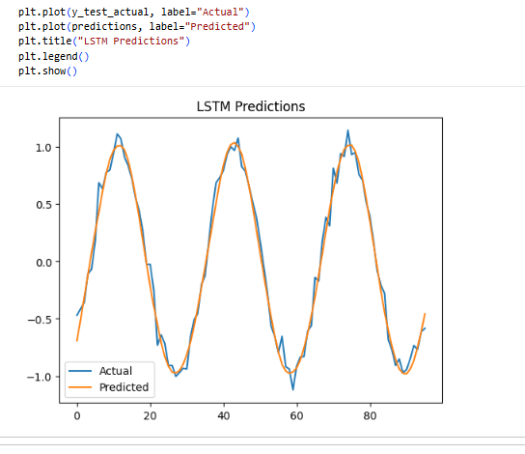
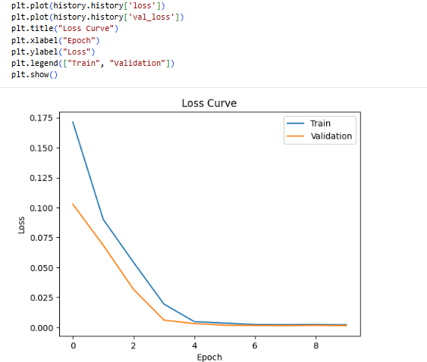
7. Analysis
1. Effect of Sequence Length
- A sequence length of 20 provided good results
- Smaller sequences may miss patterns
- Larger sequences increase computation time
2. Comparison with Simple RNN
- LSTM performs better than simple RNN
- LSTM handles long-term dependencies effectively
3. Handling Vanishing Gradient Problem
- LSTM uses gates (input, forget, output)
- This helps retain important information over long sequences
- Prevents vanishing gradient issues seen in traditional RNNs

